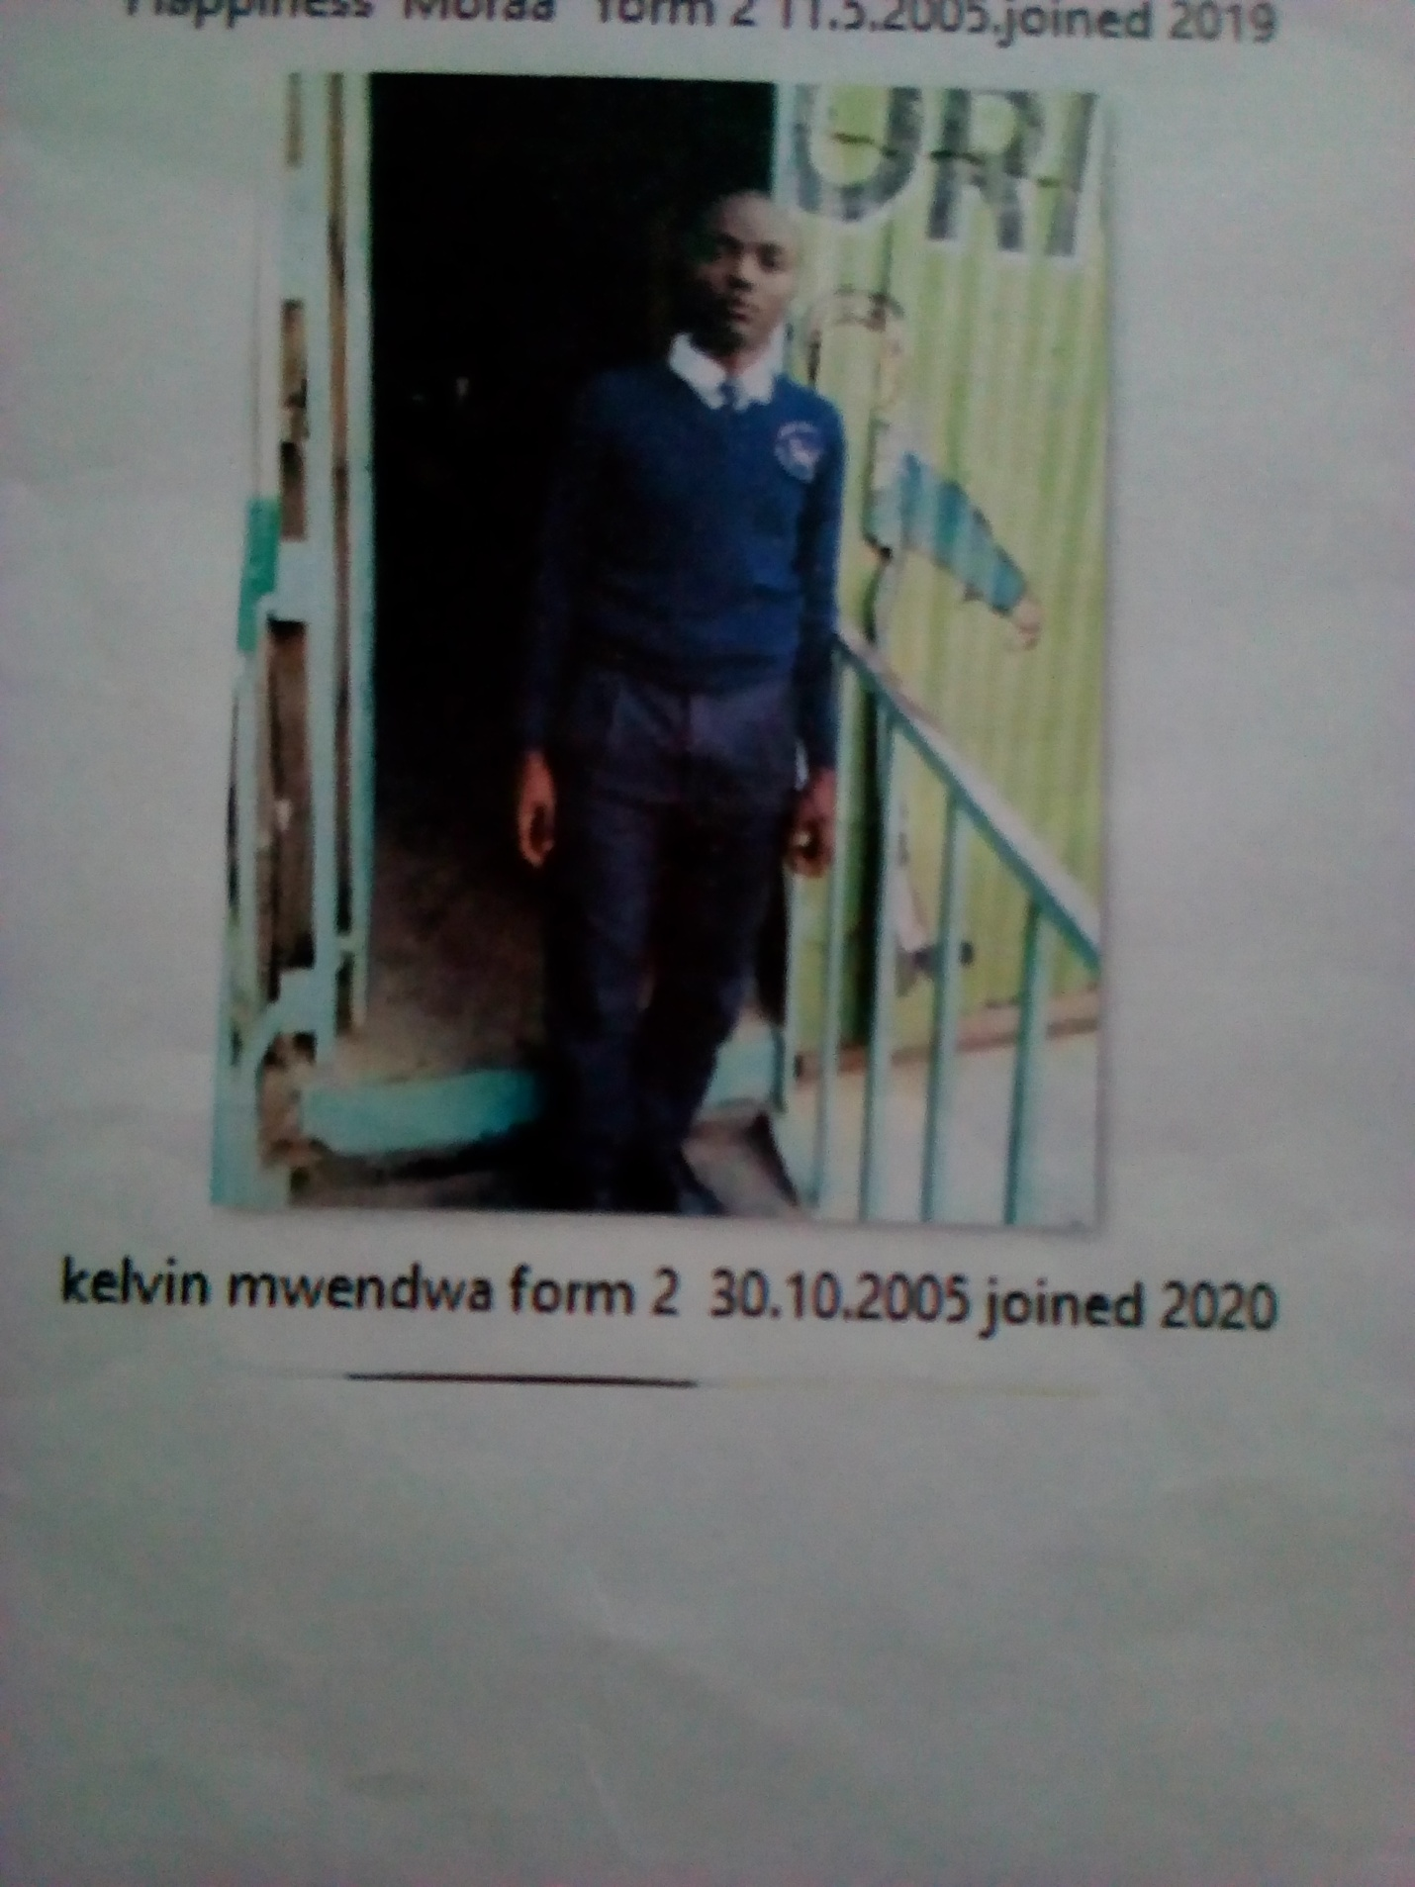

KEVIN MWENDWA FORM 2 BORN 2005 JOINED 2020
Kevin 16 years was enrolled in our school when he was 15 years old. Kevin is a need boy, her parents died of HIV. Being an ambitious young and vibrant he became a victim of drug abuse. The neighbors picked him from the streets and brought him to school for help. He was accepted in school after the Director was contacted.
Thanks to the Director Mr. Boniface Mangeti who allowed Kevin in school. I am now learning in glorious at least I have a place I call home praying that one day God will help our school have good classes, toilets and enough study materials. Thank you Michell and Brad for your support have really helped many in Mukuru

